Copyright for test papers and marking guides remains with *West Australian Test Papers.*

Test papers may only be reproduced within the purchasing school according to the advertised Conditions of Sale.

Test papers should be withdrawn after use and stored securely in the school until Friday 1st December 2017.



**SEMESTER TWO**

**MATHEMATICS**

**SPECIALIST**

**UNITS 1 & 2**

**2017**

**SOLUTIONS**

***Calculator−free Solutions***

1. (a) 1000 = 310 + 650 + 440 – 170 – 150 – 180 + *x* ✓

*x* = 100 ✓

(b) 150 – 100 = 50 ✓

(c) (i) 44 ✓

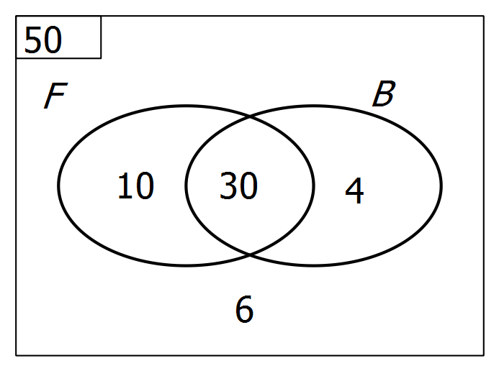 (ii)

∴ n(B) = 34 ✓✓ [6]

2. (a) (i) Substitute *z* = 2i to get (2i)4 – 2(2i)3 + 7(2i)2 –8(2i) + 12

which reduces to 0 ✓

(ii) *z* = –2i (the conjugate) is the other root. ✓

(b)  ✓

∴ 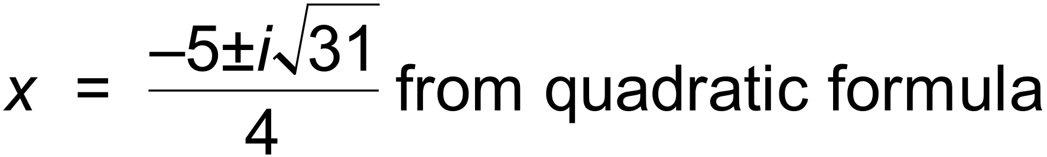 ✓✓ [5]

3. (a) (i)  ✓✓

(ii) 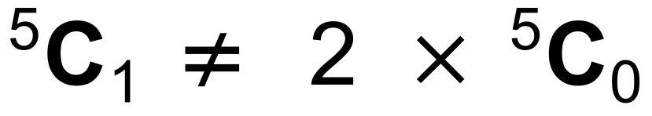 This statement is false ✓✓

(b) (i) 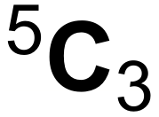 = 10 ✓✓

(ii) 2 x 4! = 48 ✓✓ [8]

4. (a) *p* = 4, *q* = 0.2 ✓✓

(b) *y* = 1 – *x* becomes y = 4[ 1 – 0.2 *x*]

i.e. *y* = 4 – 0.8*x* ✓

or, if (c) is done before (b), gradient is – 0.8 and intercept is 4

∴ *y* = 4 – 0.8*x*

(c) A′ = ( 5, 0 ) and B′ = ( 0, 4 ) ✓✓

(d) 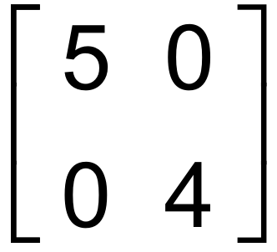 ✓✓

(e) 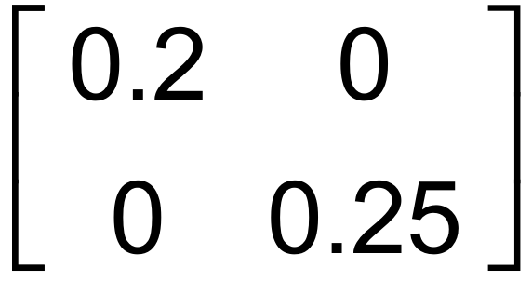 ✓✓

(f) Reflection across *y* axis

i.e. *g*(*x*) becomes – *g*(*x*) ✓✓

(g) A = 0.5 ( *ms* – *rn* ) ✓ [12]

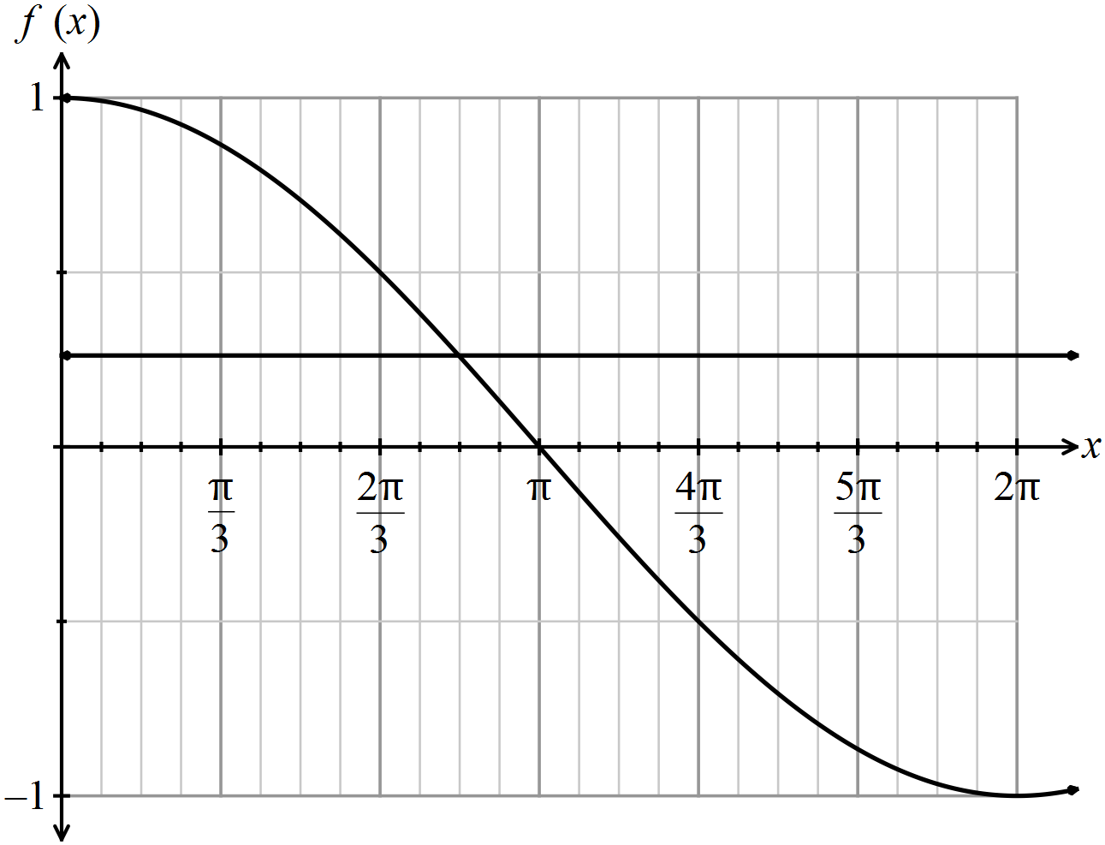5. (a)

✓✓

(b) 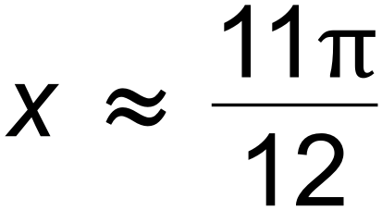line✓

of intersection and accuracy ✓✓

(c) sin *x* ✓

(d) 2cos *x* . sin *x* = sin 2*x* ✓✓ [8]

6. (a) Let the numbers be 2*k* – 1, 2*k* + 1, 2*k* + 3, 2*k* + 5, 2*k* + 7 ✓

2*k* − 1 + 2*k* + 1 + 2*k* + 3 + 2*k* + 5 + 2*k* + 7

= 10*k* + 15 ✓

Since 10*k* + 15 = 5(2*k* + 3) then divisible by 5. ✓

(b) Assume that 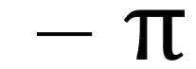 is rational, hence  = 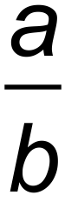 ✓

∴ 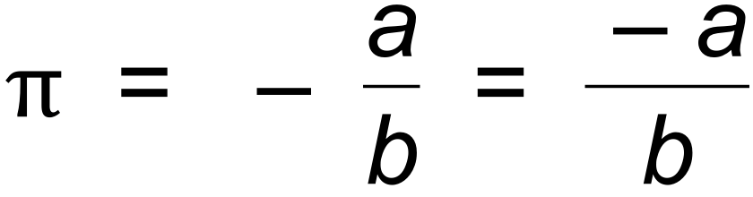 ✓

But – *a* and *b* are integers, so  is rational. ✓

This contradicts the supposition, and

therefore by contradiction  must be irrational. ✓ [7]

7. For 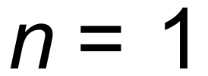:

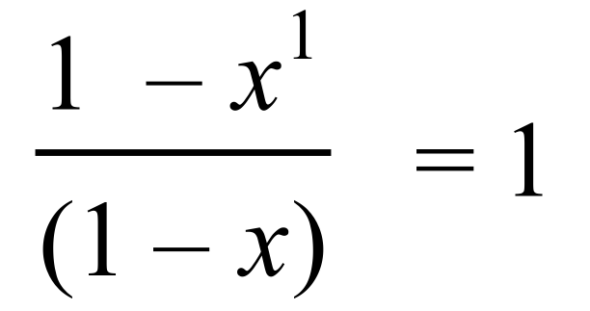 ∴ True for n = 1 ✓

Assume true for 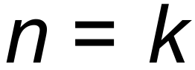:

ie 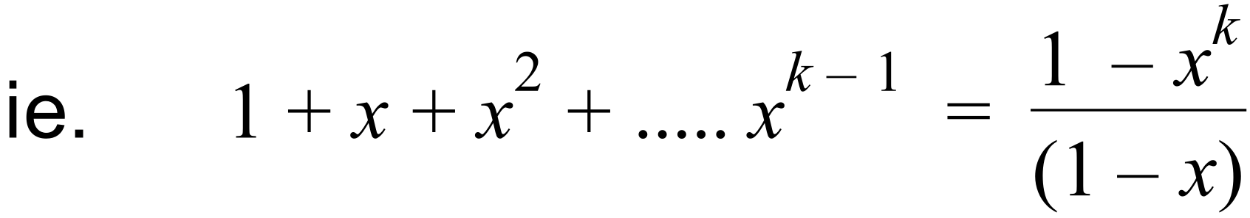 ✓

Prove true for 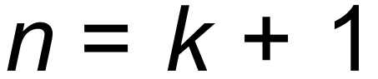:

Proof: 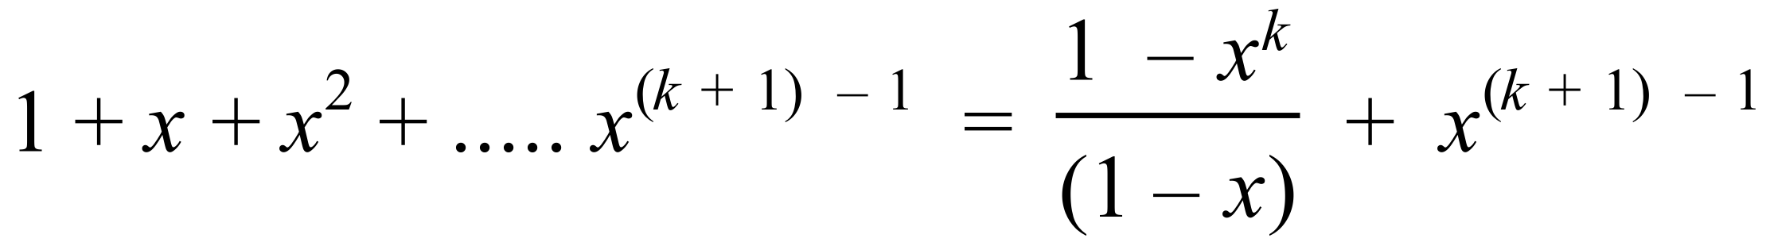

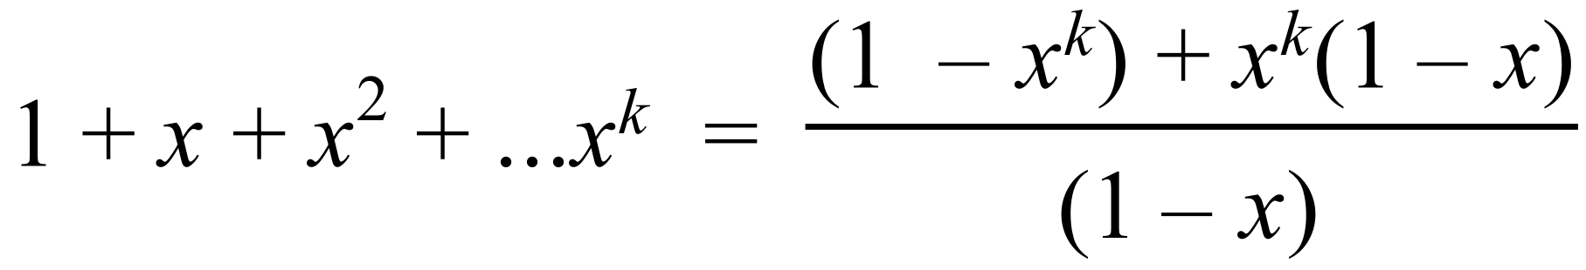 ✓

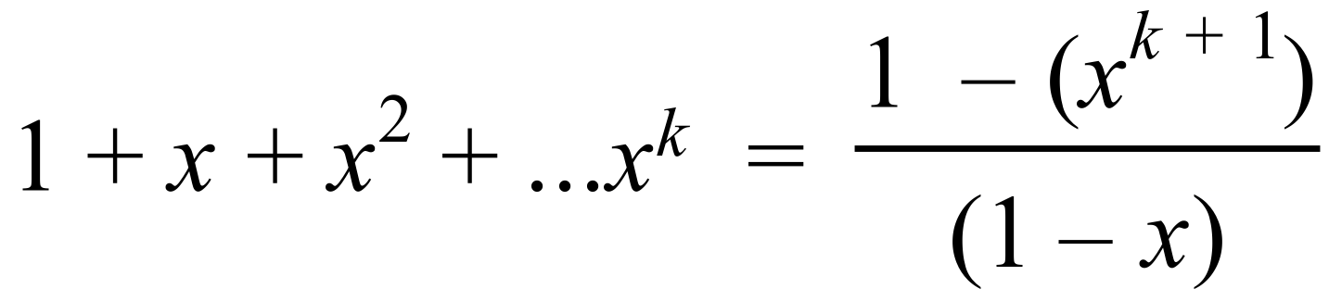 as required ✓

Therefore, True for *n* = *k* + 1, and since true for *n* =1,

true for all whole numbers. ✓ [5]

***Calculator−assumed Solutions***

8. *wz* = (2 + *a*i)(3*b* + i) = 4

∴ 6*b* + 2i + 3*ab*i – *a* = 4 ✓

∴ 6*b* – *a* = 4 and 2 + 3*ab* = 0 ✓

∴ 2 +3(6*b* – 4)(*b*) = 0 ✓

∴ 9*b*2 – 6*b* +1 = 0 ✓

∴ *b* =  and *a* = –2 ✓ [5]

9. (a) RHS = 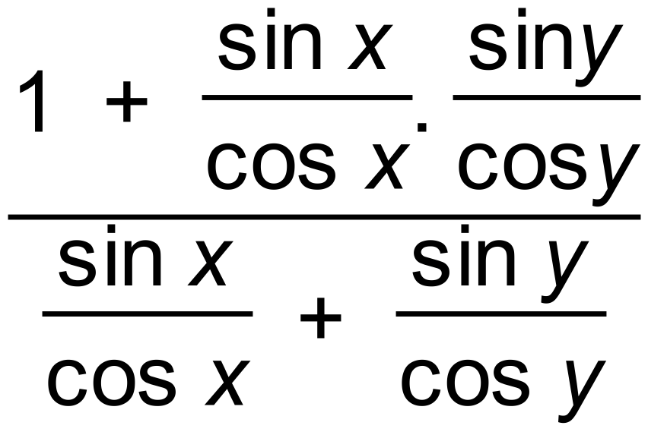 ✓

= 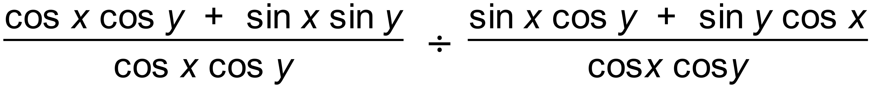 ✓✓

= 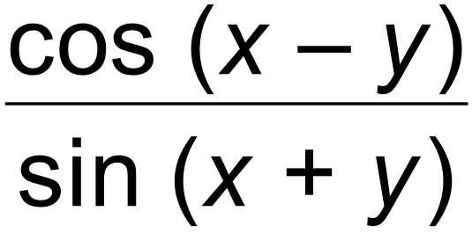 = LHS ✓

(b) (i)  ✓

and  ✓

=  ✓

= |***p***| |***q***| [ cos *A* cos *B* + sin *A* sin *B* ] ✓



(ii) cos(*A* + *B*) = cos(*A* – (–*B*)) = cos *A* cos (–*B*) + sin *A* sin (–*B*)✓

= cos *A* cos *B* – sin *A* sin *B* ✓

(iii) cos2 *A* + [cos(120 + *A*)]2 +[cos(120– *A*)]2

= cos2 *A* + [cos 120cos *A* – sin120sin *A*]2 +[cos120cos *A* + sin120sin *A*]2✓

= cos2 *A* + [ 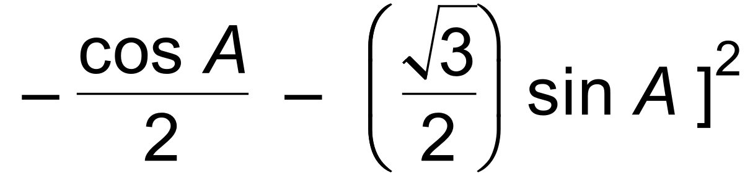 + [ 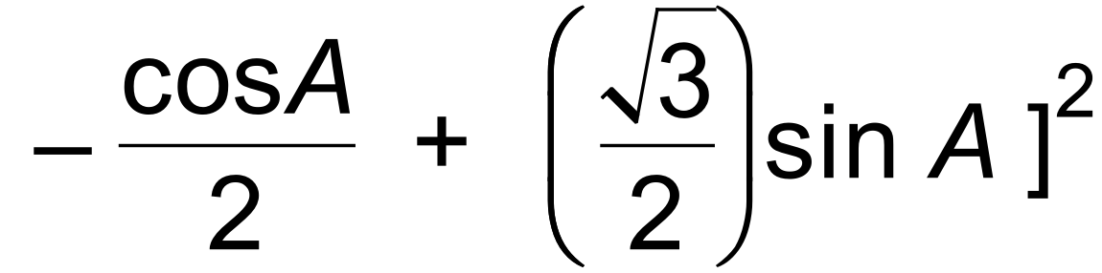 ✓

= 1.5 cos2 *A* + 1.5 sin2 *A* ✓

= 1.5 [13]

10. (a) (3**a** – **b**)  (**a** + 3**b**) = 3**a**  **a** – **b**  **a** + 9**a**  **b** – 3**b**  **b** ✓

= 3|**a**|2 + 8**a****b** – 3|**b**|2 ✓

= 3 + 8|**a**||**b**|cos 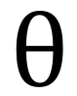 – 3 ✓

= 8cos as required ✓

(b) 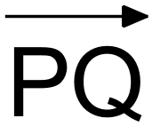 = (4,1) ✓

Unit vector on *x* axis = (1,0) ✓

Length of projection = | PQ. 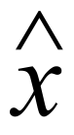 | = |4| = 4 ✓ [7]

11. (a) Let the cost of a bottle of orange concentrate cost *x*

Let the cost of a bottle of banana concentrate cost *y*

5*x* + 1*y* = 19

2*x* + 3*y* = 18 ✓

(b) 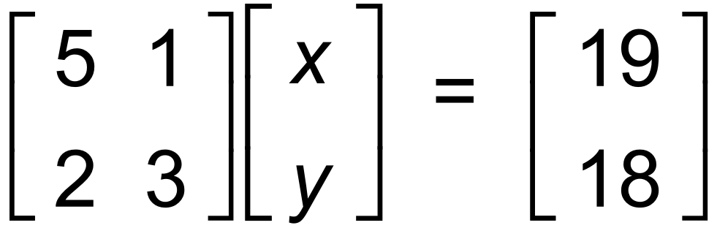 ✓

∴ 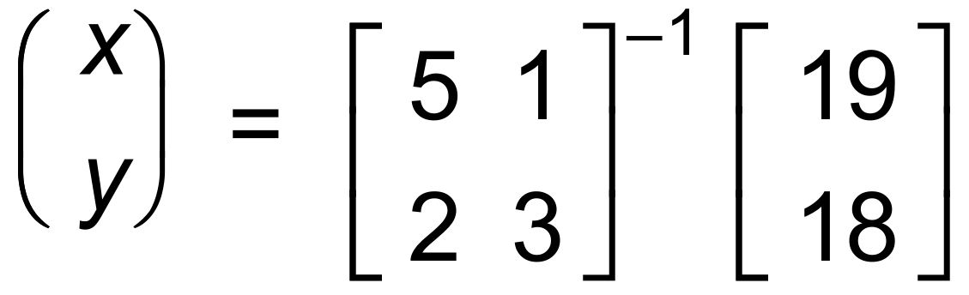 ✓

= 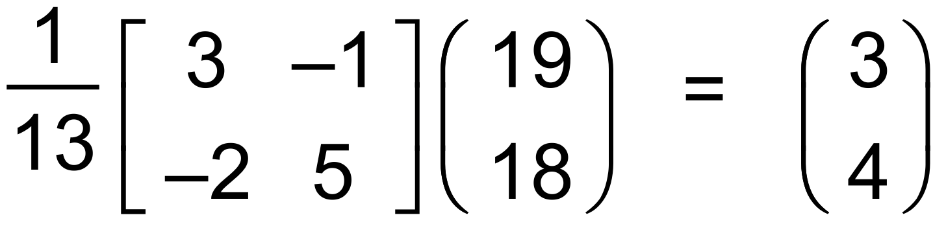 ✓ [4]

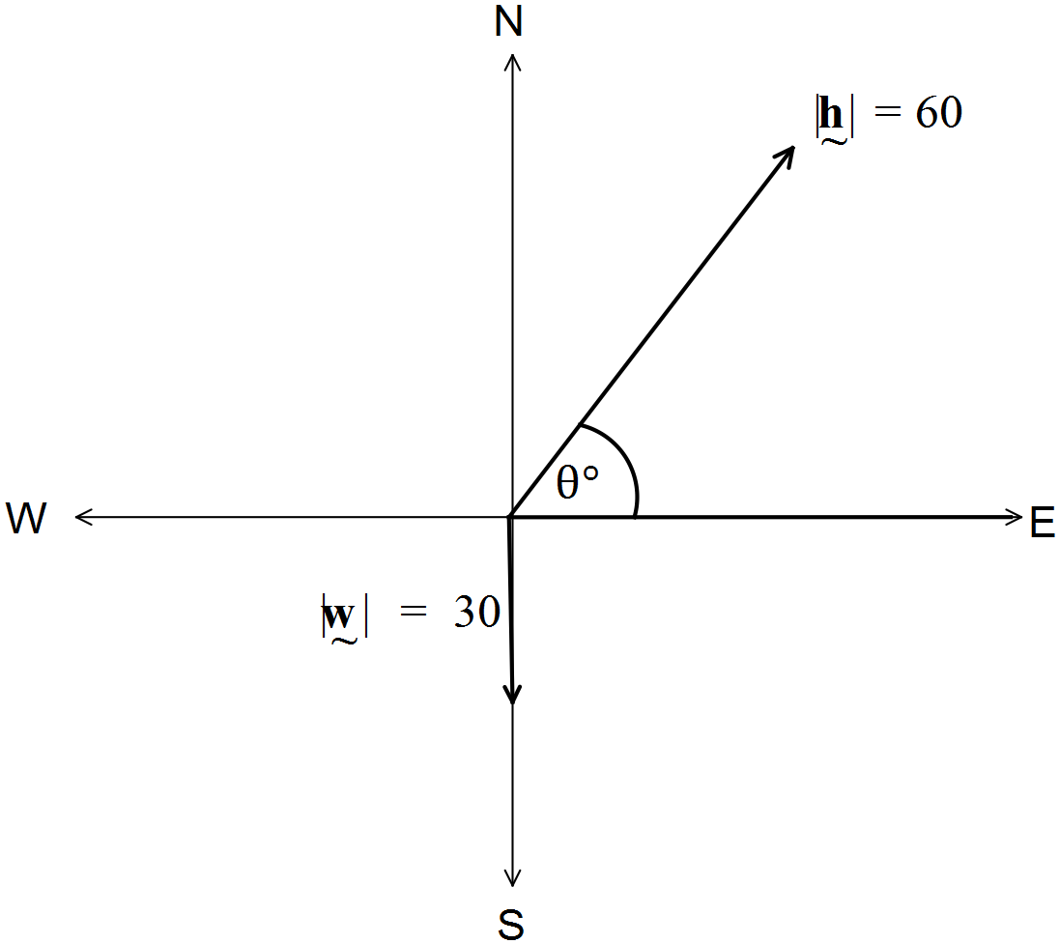12. (a)

✓✓

(b) 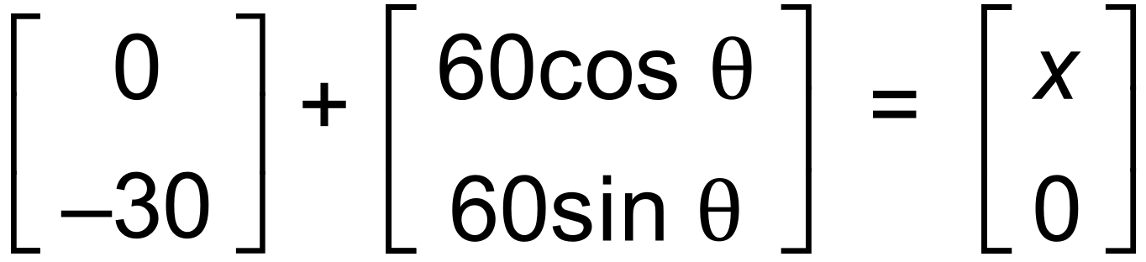 ✓✓

∴ 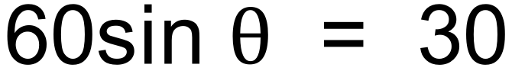 ✓

∴ 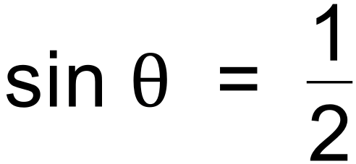

∴ = 30   Bearing is 060 T ✓

(c) Speed in Easterly direction is 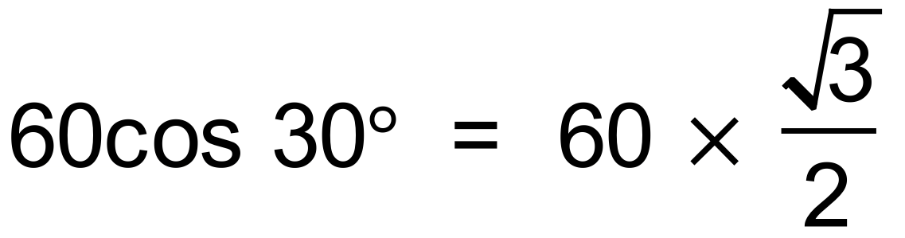 ✓

Time taken is 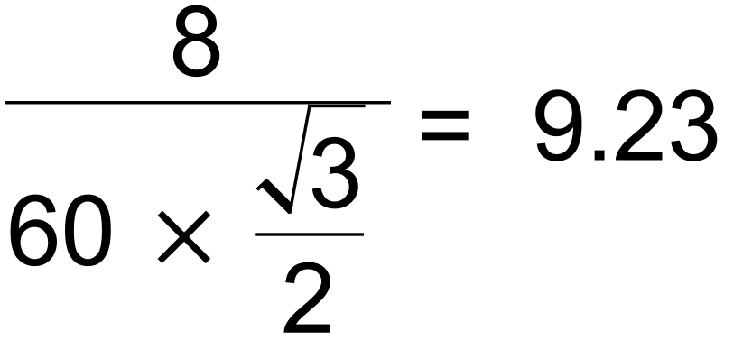 minutes ✓ [8]

13. (a) (i)  ∴ Rotation of 180° ✓✓

(ii)  ∴ Rotation of 270° clockwise ✓✓

(b) *P* = 6(*B* – 2*A*) x *B* –1 ✓

∴ 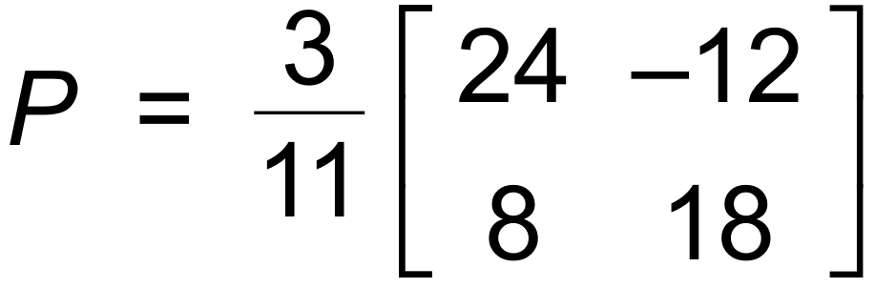 ✓✓

(c) *BA* = 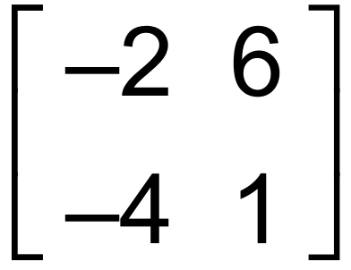

*BAX* = 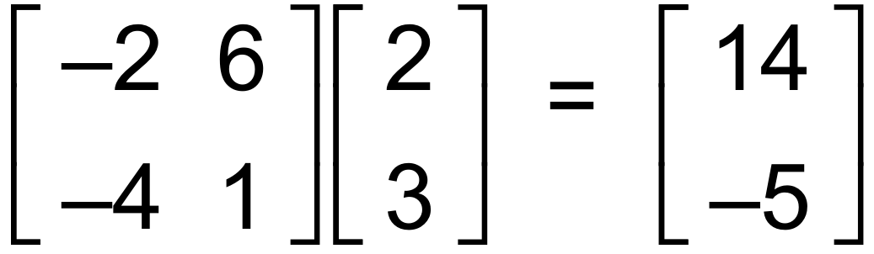 ✓

Co−ordinates are (14, −5) ✓

(d) Det B = 22 ∴ Area = 25 x 22 = 550 ✓✓

(e) Singular matrix has det = 0 ✓

∴ Area = 0 i.e. A line ✓ [13]

14. (a) 3(2**i** + 3**j**) – (*m***i** – 5**j**) = 8**i** + 14**j** ✓

∴ (6 – m)**i** + 14**j** = 8**i** + 14**j**

∴ 6 – *m* = 8

∴ *m* = – 2 ✓

(b) 2**i** + 3**j** = *k*(*m***i** – 5**j**) ✓

∴ 2 = *km* and 3 = –5*k*

∴ *k* = – 0.6 and by substitution, *m* = 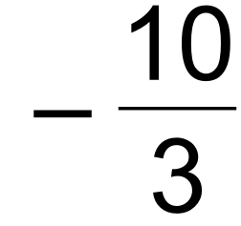 ✓

(c) 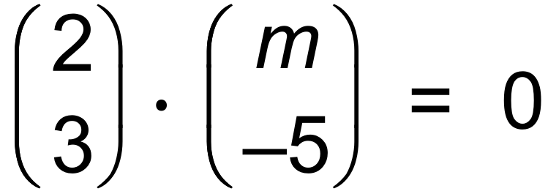 ✓

∴ 2*m* – 15 = 0

∴ *m* = 7.5 ✓ [6]

15. (a) 

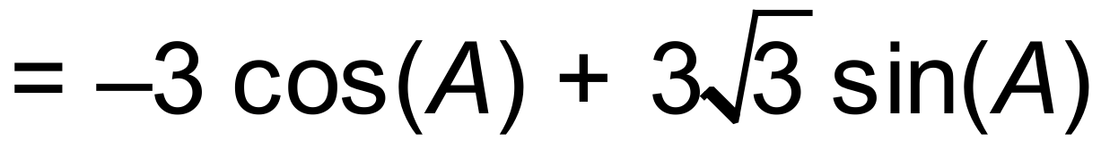



hence, 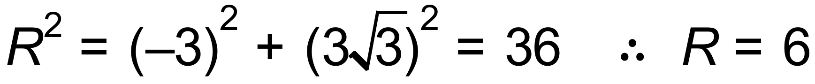 ✓✓

and 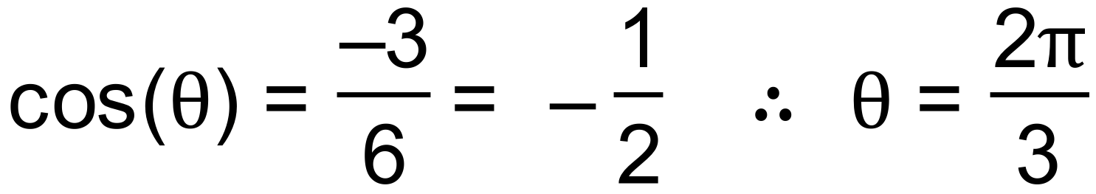 ✓

therefore, 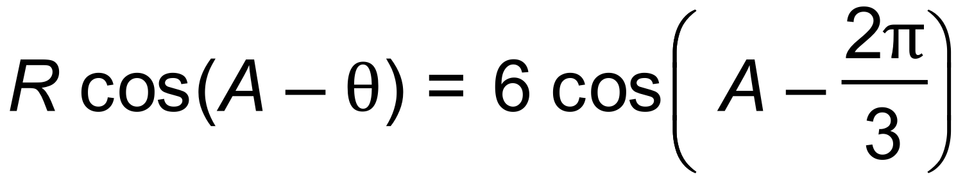 ✓

(b) (i) 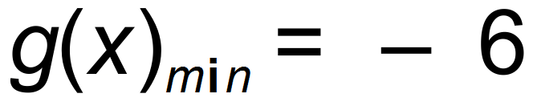 ✓

(ii) for 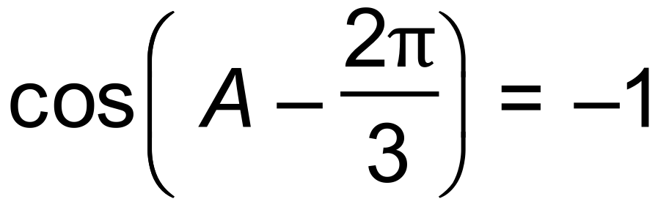

hence 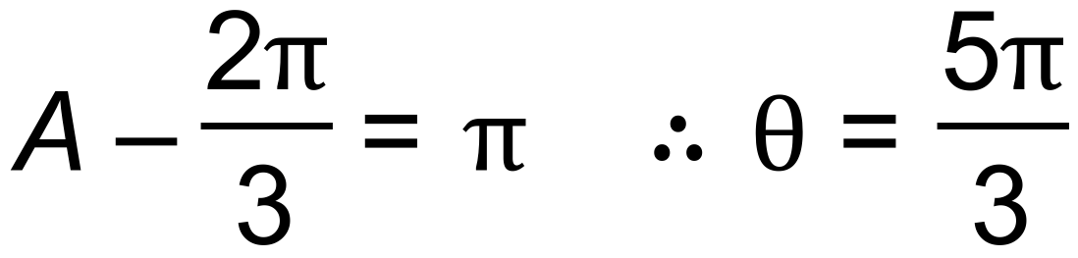 ✓✓ [7]

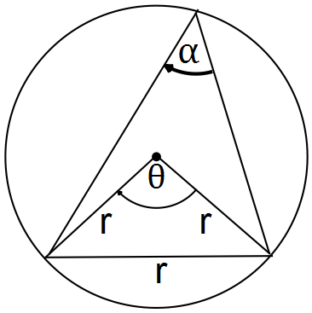

16. (a) 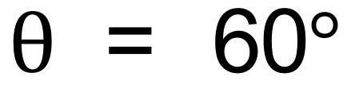 (equilateral triangle) ✓

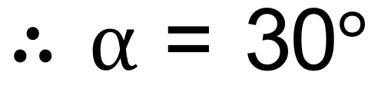 (central angle theorem)✓

(b) (i)

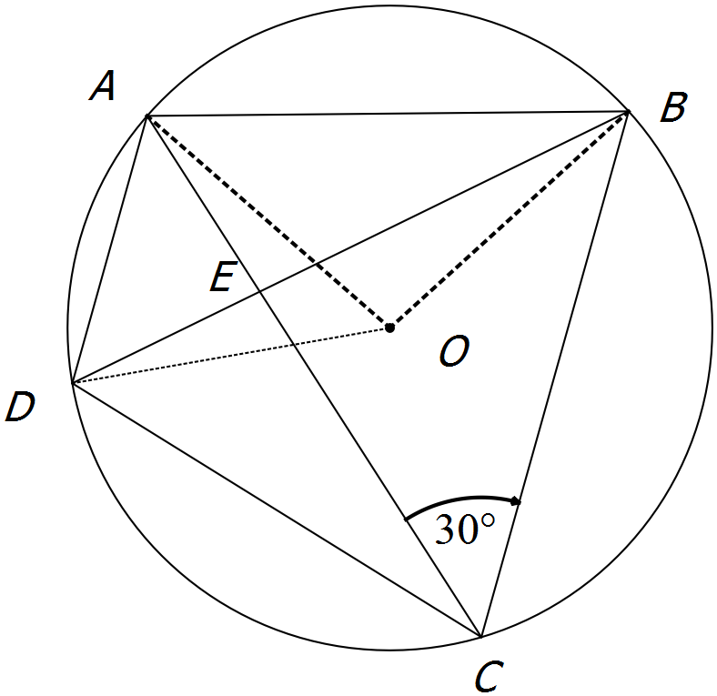

*AOB* = 60 (proved in (a))

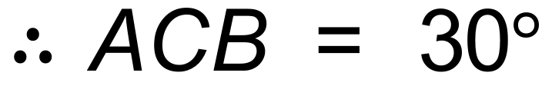 (theorem)

Similarly, *DBC* = 30

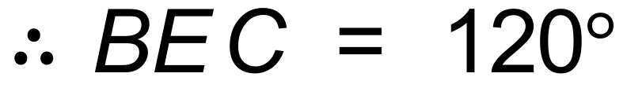

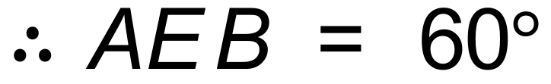 ✓✓✓

(ii) Assume E is the centre.

All angles of ABE = 60 

and all angles of BEC = 60 

But 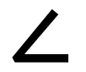AEB = 2ACB which is impossible if they are both 60 

 E is not the centre. ✓✓✓ [8]

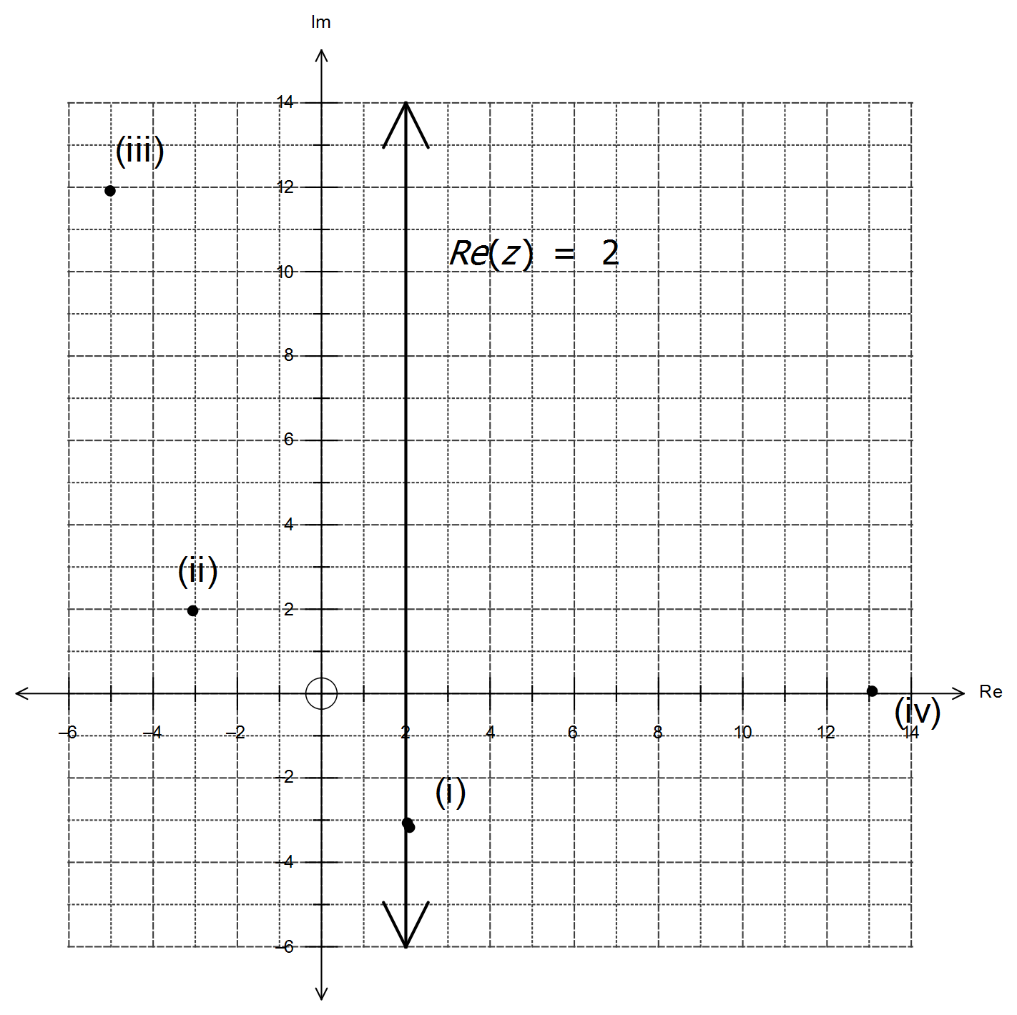

17. 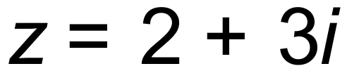

(i) 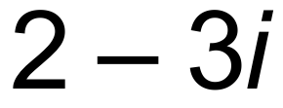 ✓✓

✓✓

(ii) 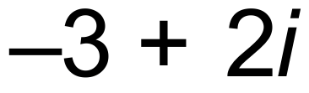 ✓✓

(iii) 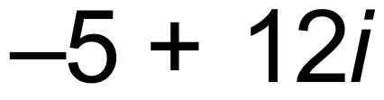 ✓✓

(iv) 13✓✓

✓✓

[8]

18. (a) 2m ✓

(b) 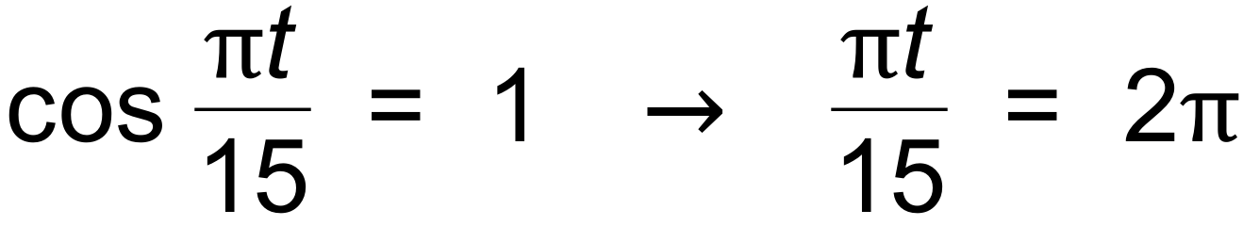 ✓

∴ t = 30 secs ✓

(c) 138m ✓

(d) 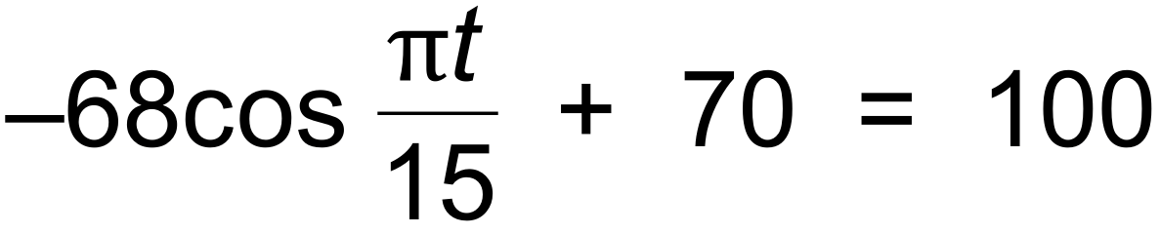 ✓

∴ *t* = 9.68, 20.32 ✓

∴ 10.64 minutes ✓ [7]

19. (a) It is given that 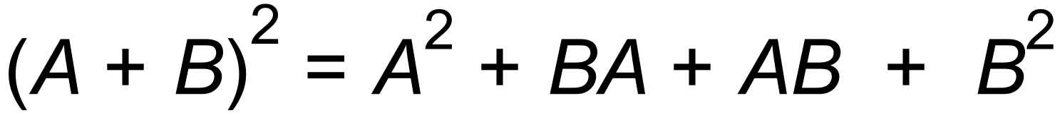 ✓

Since *AB*  *BA*, ✓

∴ 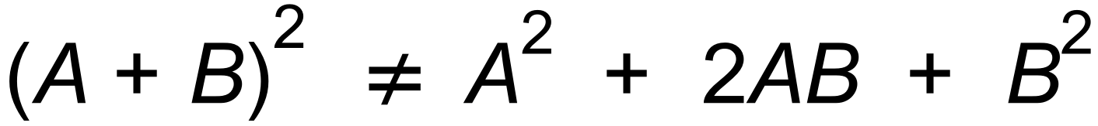

(b) 

∴  ✓

∴ 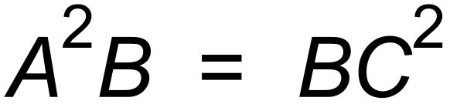

∴ 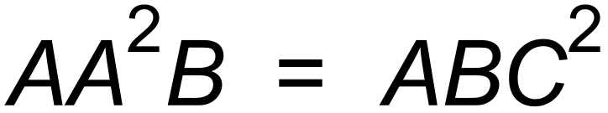 ✓

∴ 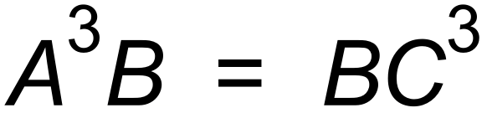

∴ 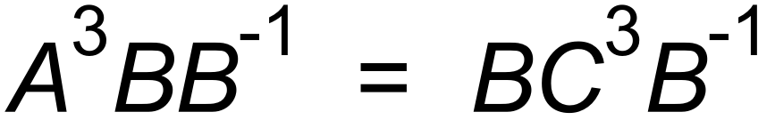 ✓

∴ 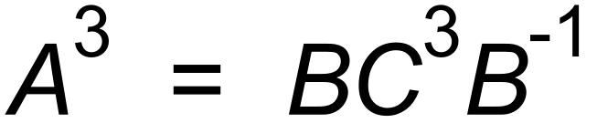 as required ✓ [6]

20. (a) 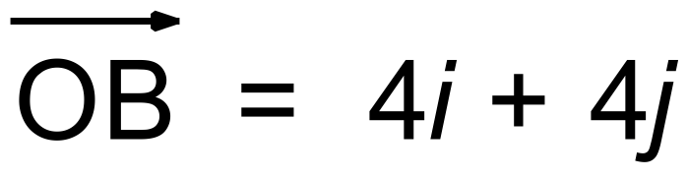 ✓

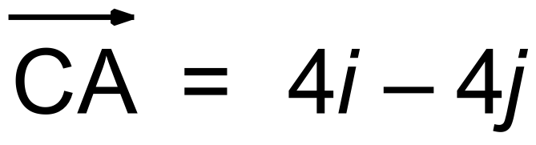 ✓

(b)  ✓

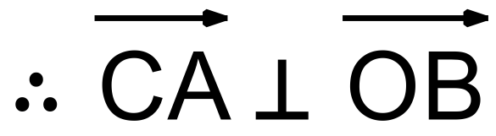 ✓

(c) Let k be the midpoint of 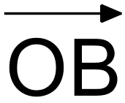.

Then K = (2, 2)

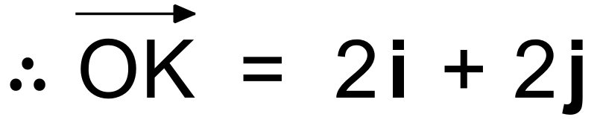 ✓

So  ✓

 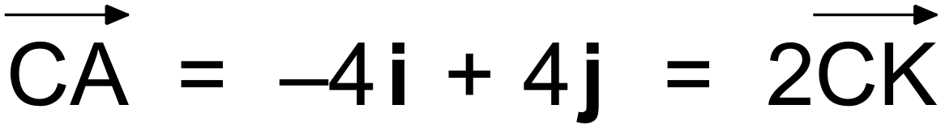

∴ K is the midpoint of 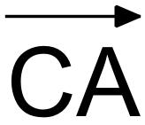 ✓ [7]

∴ Diagonals bisect each other.